CURRICULAM VITAE

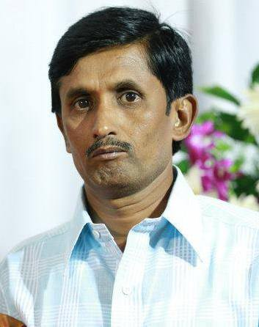

Sripad B Desai
# 461/1, Ground Floor,
2nd ‘D’ Main, M.E.S.Road,
Mutyalanagar,
Bangalore-560 013 Mobile No. 8867127335

Email: sripad.desai@gmail.com
______________________________________________________________________

Carrier Objective:

To develop my professional skills using my academic background & build a flourishing professional career in the field of Finance to work in a dynamic and challenging environment.

Previous Employment: -

- Name of the Organization: - Hospet Foods Pvt.Ltd
Designation : - Executive Accounts
Duration : - Sep 2005 to Mar 2007

- Name of the Organization: - Basavarajeshwari Eng.Works
Designation : - Executive Accounts
Duration : - Apr 2007 to May 2011

- Name of the Organization: - Sree Vittal Transport Contracts
Designation : - Executive Accounts
Duration : - Apr 2011 to Sept 2015

Contd…..2

2

Job Profile:

- Preparation of Bank Reconciliation Statement
- Maintaining Purchase & Sales Invoices
- Maintaining Employees Register
- Entering Purchase & sales details in Tally
- Entering service tax invoice and preparing service tax statement
- Preparing statement and e-filing of Service Tax , EPF & VAT
- Preparing the Profit and Loss Accounts & Balance Sheet

Educational Background: -

B.com from Gulbarga University in 1989

Computer Skills:
Operating System Windows 98/XP
Application MS- Excel, MS-Word, Tally.ERP 9 Latest Version i.e 4.93
Online Filing (VAT & Service Tax)
Net Banking

Present working:
Presently working in Hareesh & Co, Chartered Accountant, 6th Block Rajajinagar as
Accounts Executive.And also I am working some part time jobs in Bangalore

Area of Specialization:

Accounts, Banking
Hobbies :

Reading, Traveling and Listening to Music.

Language Known:

Kannada, English and Hindi

Strengths:

Hardworking and confidant
Analytical, logical & problem solving skills.

Contd…..3

3

Personal details:

Date of Birth 01.06.1966
Nationality Indian
Religion Hindu
Marital Status Married
Contact Address # 461/1, Ground Floor,
2nd ‘D’ Main, M.E.S.Road,
Mutyalanagar,
Bangalore-560 013

Date: Yours faithfully
Place: Bangalore
(Sripad B.Desai)

Full Name: Sripad Desai
Age: 50
Qualification: B.Com
Current Company: Hareesh & Co, Bangalore
Total Exp.: 14+
Current Salary: 15000
Excepted Salary: 25000
Date of Joining: 15 Days
Reason for leaving current com.: For getting better job & salary

